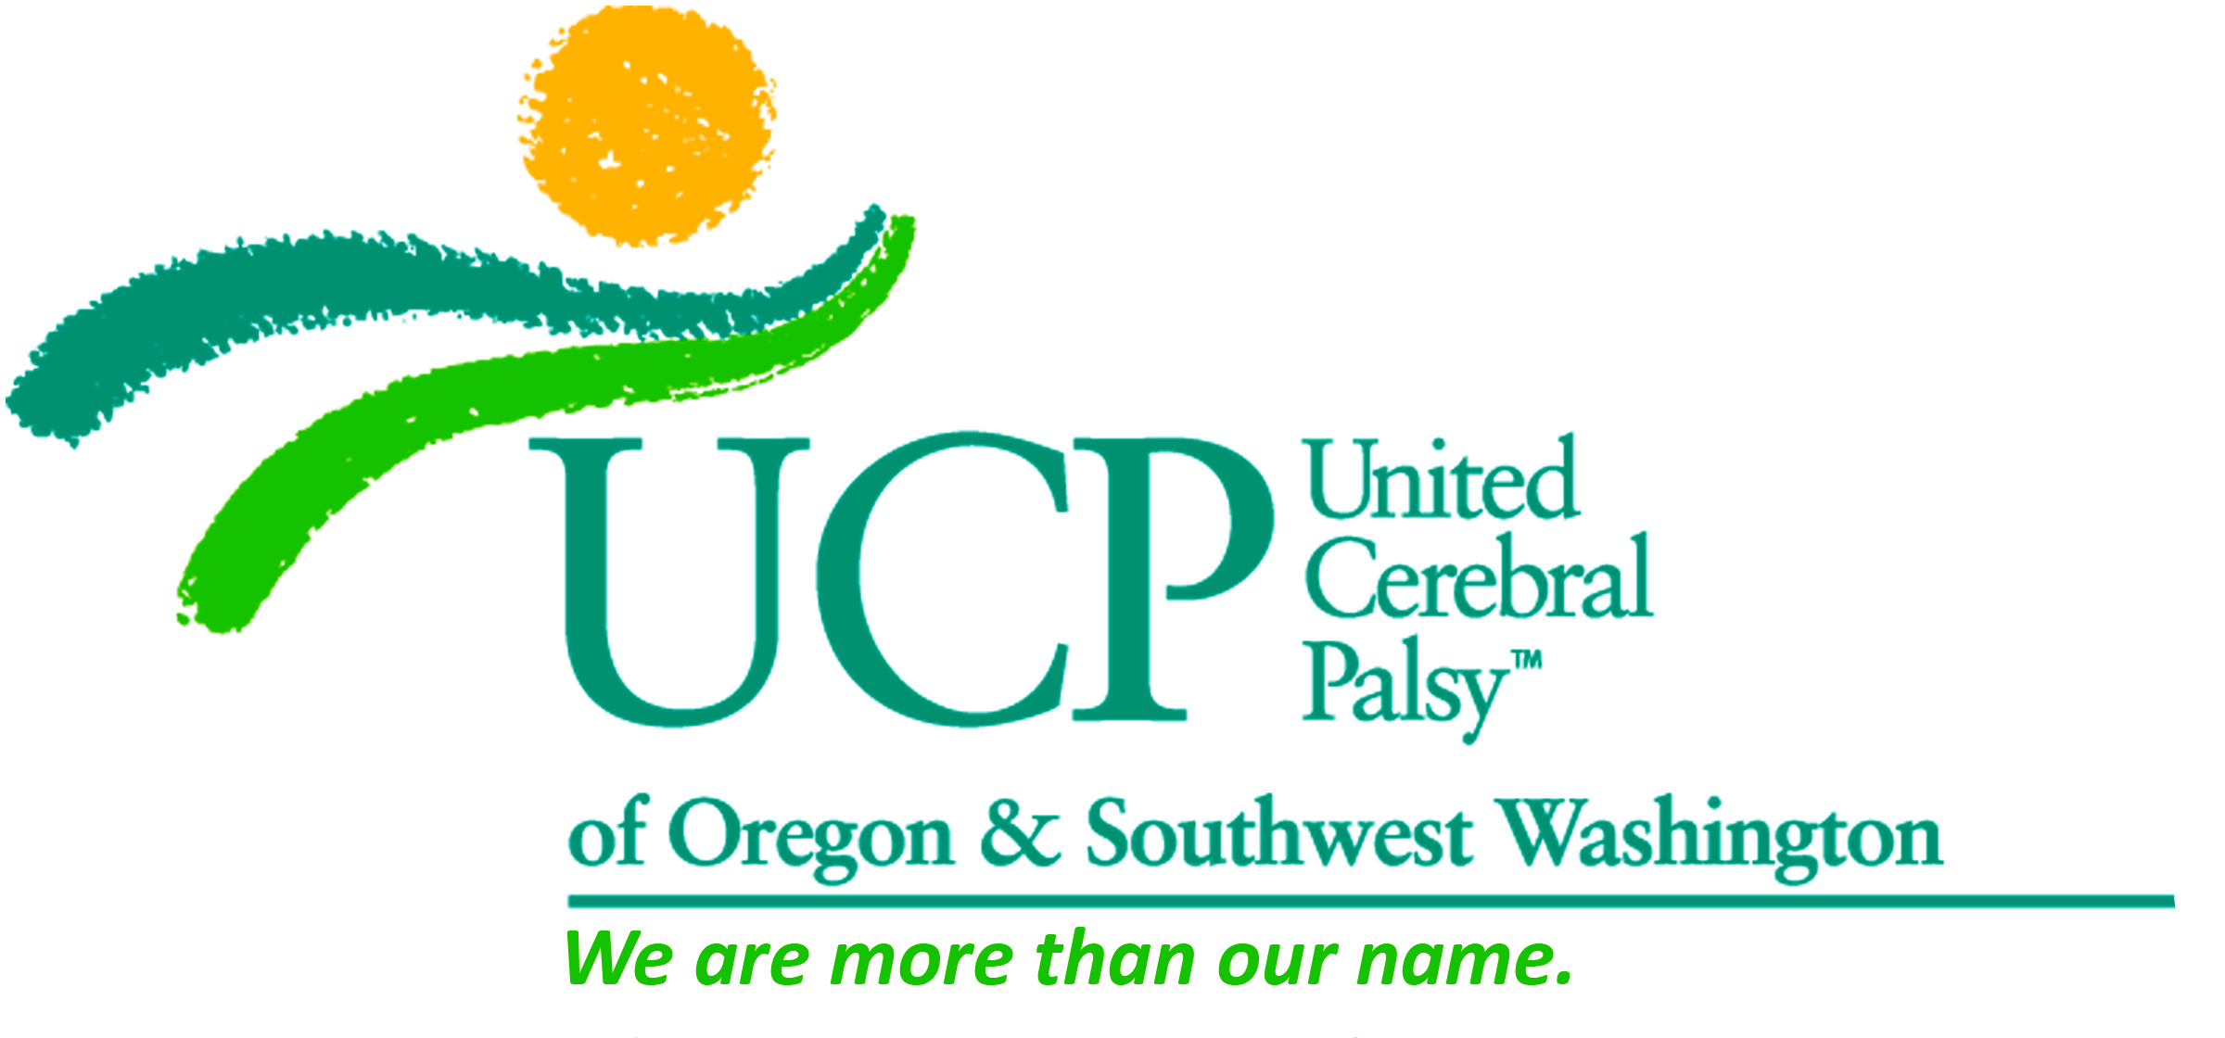
United Cerebral Palsy of Oregon & SW Washington
305 NE 102nd Avenue, Suite 100 | Portland, Oregon 97220
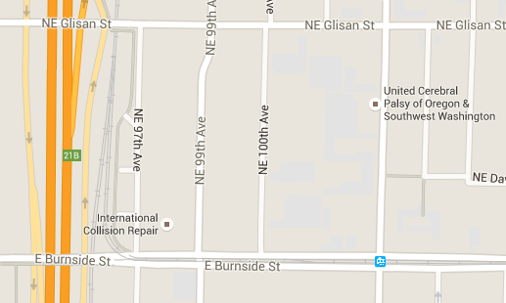
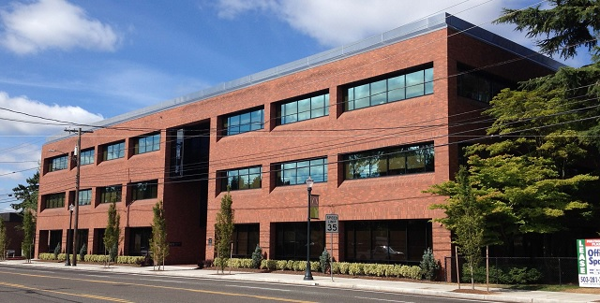
X

LOCATION:
- The UCP office is located in a 3-story brick building named “Multnomah Plaza.”
- Our address is 305 NE 102nd Avenue (which is south of NE Glisan and north of E Burnside).
- Look for us on the west side of the street. Our driveway is just south of the building, and the parking lot is behind the building.
- Park in “visitor” parking or in spots 86-96 or 107-117.

WHEN YOU ARRIVE:
- Enter the building lobby. Enter the first door on your right on the ground floor.

DIRECTIONS FROM THE WEST:
- Take I-84 E to Exit 7 for Halsey St (toward Gateway District)
- Go through Glisan St intersection
- Multnomah Plaza will be on the right
- If you get to Burnside, you’ve gone too far

DIRECTIONS FROM THE EAST:
- Head west on Burnside
- Turn right on NE 102nd Ave
- Multnomah Plaza will be on the left
- If you get to Glisan, you’ve gone too far

DIRECTIONS FROM THE NORTH:
- Take I-205 S
- Take Exit 21A for Glisan St toward Stark St
- Turn left onto NE Glisan St
- Turn right onto NE 102nd Ave
- Multnomah Plaza will be on the right
- If you see Burnside, you’ve gone too far

DIRECTIONS FROM THE SOUTH:
- Take I-205 N to Exit 21A for Glisan St
- Turn right onto NE Glisan St
- Turn right onto NE 102nd Ave
- Multnomah Plaza will be on the right
- If you get to Burnside, you’ve gone too far

